Let Experienced Pilots Fly, Inc.
NOTAM #26
“EXPERIENCE MATTERS”
December 11, 2025
This update includes:
• Experience Gap Article
**As the Christmas holiday celebrations approach us, we want you to know that we remain fully engaged in our communications and meetings with congressional allies, as well as developing new support.
Our LEPF president, Capt. Barry Kendrick is in Washington, DC to meet with some members of the House Transportation & Infrastructure Committee, as well as the House Sub-Committee on Aviation. (See photos, below)
Additionally, Barry continues to meet with Senate staff and our lobbyist firm to further impress the urgency of re-introduction. We expect substantive information before Congress adjourns for the Christmas break.
As we reported last week, congressional staff seem to be caught up after the government shutdown. So, our expectation is that our “LEPF Act” (bill) will be re-introduced very soon.
Recall that earlier this fall our House Champion Rep. Troy Nehls reintroduced the “Let Experienced Pilots Fly Act of 2025” in the House.
**Flying magazine published a really interesting article recently. In it, the largest US pilot union is stating the obvious; “…the industry recognized the need for more manual flying through safety data that showed pilots’ hands-on skills were beginning to erode.”
https://www.flyingmag.com/alpa-urges-back-to-basics-approach-to-pilot-skills/
This dovetails what we have been impressing upon Congress, that due to the pilot shortage, airlines are hiring pilots with the minimum required experience, thus creating the “experience gap” in the major airlines operating heavy jet transport equipment.
A seasoned pilot recognizes that hand-flying skills must be kept up. The inexperienced pilot is far too eager to (as the article quotes) call “positive climb, gear up, autopilot on”. This is much too common today and airlines’ Flight Operations Quality Assurance (FOQA) data supports it, as the article highlights.
An experienced pilot recognizes the need to maintain hand-flying skills. The fact that this article is being published to remind pilots of this basic flying skill speaks directly to LEPF’s three-year message: EXPERIENCE MATTERS!
There is no better investment into your financial future than helping us help you. We are all unpaid volunteers, some of us already retired, but passionate about our work. We need your financial contributions to get this over the line.
Please contribute HERE
Thank you for your continued support.
The burden of proof should be on the agencies that restrict the pilot license privileges at a certain age, to justify why they do so, because EXPERIENCE MATTERS!
In Unity,
Let Experienced Pilots Fly
Postscript: Last night we attended a private dinner honoring members of the House Transportation and Infrastructure Committee, hosted by Chairman Sam Graves, a LEPF supporter. In these photos top: LEPF President Captain Barry Kendrick with Chairman Graves (R-MO) and bottom: T&I member and Foreign Affairs Chair Brian Mast (R-FL). Our participation in these important events is possible due to the relationships we have built and maintain with our members’ support. Thank you.
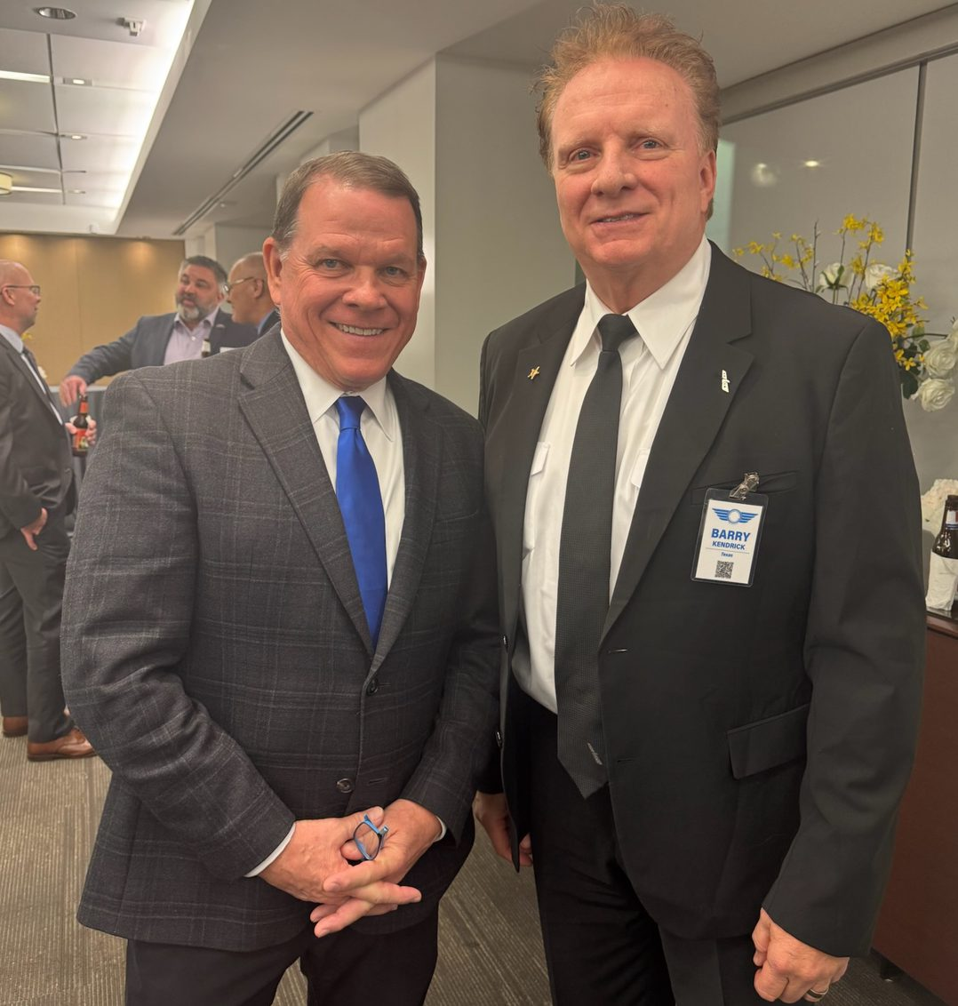
.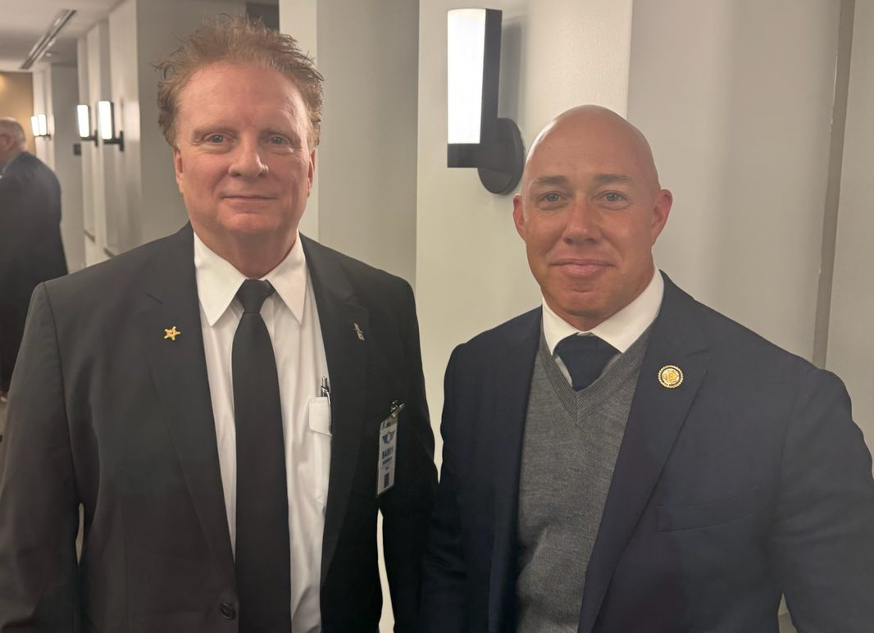
PHOTO TOP: House Transportation and Infrastructure Chair Sam Graves (R-MO) with Capt. Barry Kendrick, LEPF President, who was invited to attend the Transportation Trust Dinner on Dec11, 202510, 2025 in DC.
PHOTO BOTTOM: House T&I Committee Member and Chair of the House Foreign Affiars Committee Brian Mast (R-FL) spent time with LEPF President Capt. Barry Kendrick, and echoed support for our bill.

