Let Experienced Pilots Fly
NOTAM #33
“EXPERIENCE MATTERS”
March 23, 2026
Dear LEPF Members,
We have had a draft NOTAM ready to send announcing the Senate LEPF Bill introduction announcement since the Fall of 2025.
As we were told time and time again that we would have a Thanksgiving surprise, then Christmas, New Year’s, then…. You know the story as you have continued being engaged in spite of the goal post being moved month to month, to the point of our highest frustration and disappointment.
Recently, we were hopeful of a little St. Paddy’s luck with a surprise in the last week. Every day that goes by 17 or so airline pilots are forced out of the profession they love, and thrown out the door.
We could not be more sympathetic, and actually empathetic, because some of us have already been discriminated against due to a birthday. We feel your pain and hear your angst.
Our lobby team is aggressively trying to get Senator Graham to meet his promise to introduce the LEPF Bill. Scheduling another meeting with him is in process and we hope to have some more news by next week. Your response to our Call to Action did have an impact in his office and they are keenly aware of our prioritization of this legislation.
LEPF President Capt. Barry Kendrick attended a luncheon, last week, for Congressman Sam Graves, Chair of the House Transportation & Infrastructure Committee, where DOT Secretary Sean Duffy was the keynote speaker. Barry met with Sec. Duffy and had an engaging conversation with him.
Barry’s comments to the group included informing them that approximately 17 pilots are forced to retire every day, due to age discrimination, and asking everyone in attendance if they preferred highly experienced pilots in the cockpit? The response was clearly in the affirmative and Barry then asked that they support Chairman Graves’ efforts to eliminate or raise the pilot retirement age. His conversation with Secretary Duffy included a plea to end unions dictating statutory law.
Additionally, Barry met with Congressman Lloyd Doggett and will meet again for further development of his support around April 22-23 during a potential fundraising event. As we continue to express our views to congressional leaders, the opposition to age discrimination is growing.
We are addressing our frustration at every angle possible and want to make sure you know that we are not just being hopeful, but aggressively pursuing the Senate bill introduction.
We will not stop until we get a Senate bill, however we continue to pursue any other avenues to eliminate/raise the age.
Thank you for your continued support. We could not do our work without you.
The burden of proof should be on the agencies that restrict the pilot license privileges at a certain age, to justify why they do so, because EXPERIENCE MATTERS!
In Unity,
Let Experienced Pilots Fly

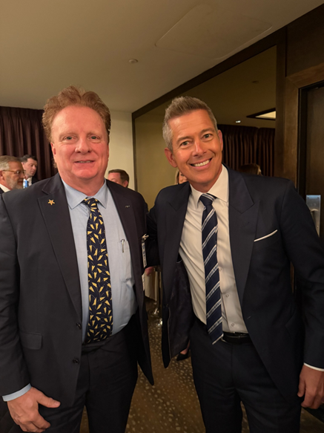
LEPF President Barry Kendrick and Secretary of Transportation Sean Duffy at a luncheon honoring Transportation and Infrastructure Chairman Congressman Sam Graves (R-MO) - Washington, DC 3/19/26

