Let Experienced Pilots Fly
NOTAM #48
“EXPERIENCE MATTERS”

September 23, 2026
Dear LEPF Members,
On September 9, 2026 LEPF board of directors member Capt. Steve Scheibner (of the Capt. Steeeve YouTube channel) conducted an interview with Kennedy Steve that included FAA Administrator Brian Bedford.
In this interview Capt. Steve asked Mr. Bedford, among other topics, about his position on the mandatory pilot retirement age.
Mr. Bedford expressed his personal view that an automatic retirement age is "silly," provided pilots can maintain the required medical certifications. He notes that while there are logistical challenges regarding international standards and pilot training, keeping experienced aviators in the cockpit could be a competitive advantage and help mitigate the pilot shortage. Additionally, Mr. Bedford said that his personal position is that there should be NO AGE.
Here is a link to the video excerpt, starting at 36:50 where the pilot retirement age is discussed.
https://youtu.be/Kr8T1IhRgrI?is=UFsEcs3-anQsWj_n
To watch the entire Captain and Kennedy Air Show featuring Administrator Bedford, click in the graphic below.

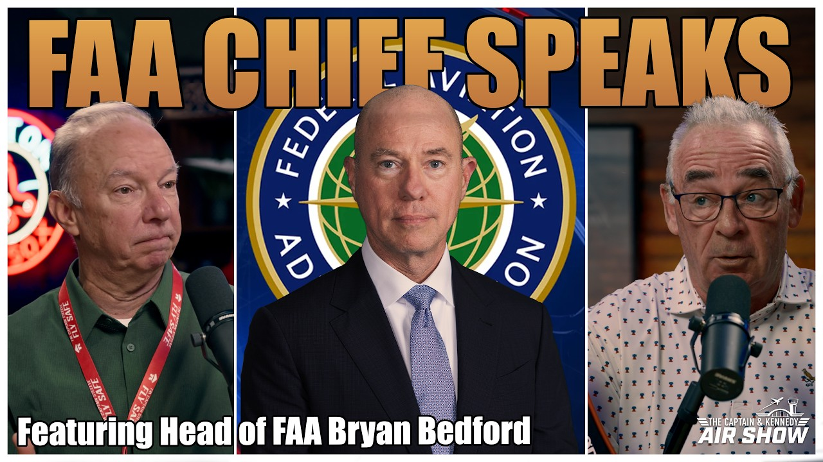
Notice that he agrees there is a pilot shortage, contrary to the propaganda ALPA is spreading. We continue to work on your behalf and will leave no stone unturned in our efforts to change this arbitrary and capricious age-discriminating law.
There is no better investment into your financial future than helping us help you. We are all unpaid volunteers, many of us already retired, but passionate about our work. We need your financial contributions to get this over the line.
Please contribute HERE
Thank you for your continued support.
The burden of proof should be on the agencies that restrict the pilot license privileges at a certain age, to justify why they do so, because EXPERIENCE MATTERS!
In Unity,
Let Experienced Pilots Fly

